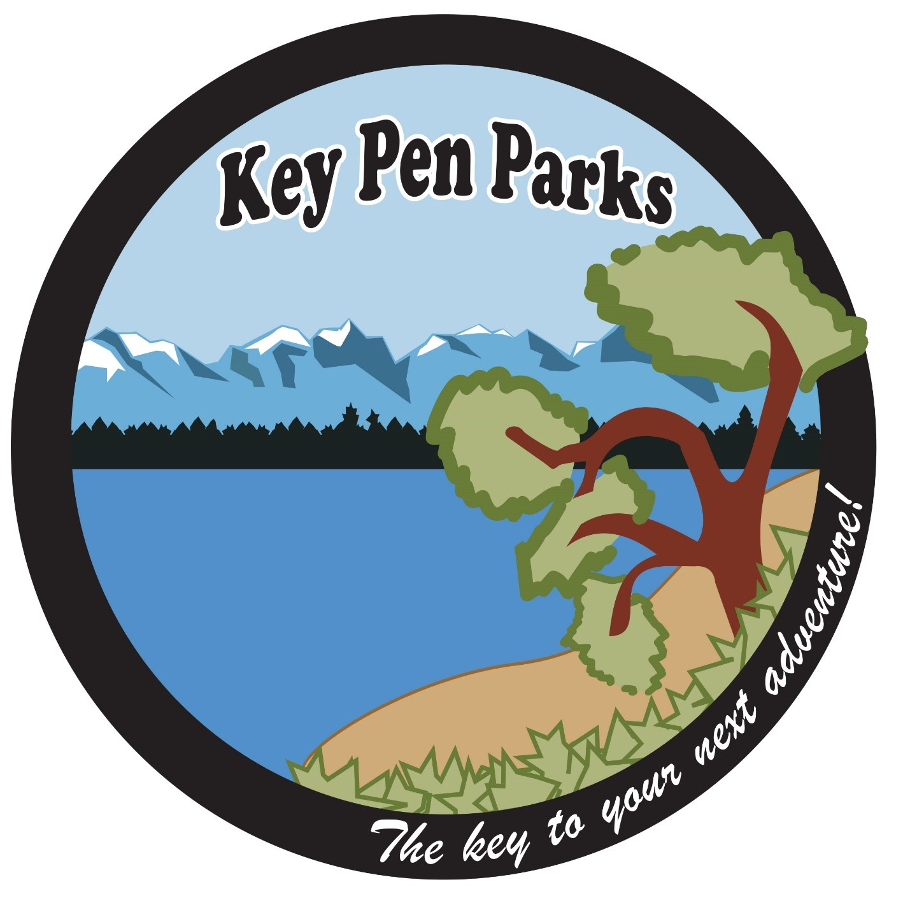 VOLUNTEER HANDBOOK
Jake Gleason
Volunteer & Office Coordinator
Jakeg@keypenparks.com
Mobile: 253-358-5465
Updated April 2021

Welcome!

Thank you so much for your interest in helping Key Peninsula Metropolitan Park District, DBA Key Pen Parks, Volunteers are vital to the success of many of our programs and special events as well as beautification and maintenance of our parks and facilities.

Volunteers are an important part of our team; therefore, we have prepared this handbook for you, which details our volunteer policies, procedures, and responsibilities. Please read through this handbook carefully. It is designed to provide you with the information necessary to make your volunteer experience with Key Pen Parks both safe and rewarding.

Thank you again for your commitment and contribution to Key Pen Parks, please feel free to contact us with any questions, issues, or ideas so we can make the most of your volunteer service.

Table of Contents 1
Volunteer Process 2
Types of Volunteers 3
Policies and Procedures 4
Park Sites and Addresses 7
Contacts 7

The Volunteer Process

Thank you so much for your interest in making a difference in our parks and our community. Volunteers have an incredible and often immeasurable impact on our parks and natural areas and are vital to the success of many of our programs and special events here at Key Pen Parks.

Application Requirements
Volunteers must be age 16 or above unless volunteering alongside a parent or guardian. A completed volunteer application including a waiver of liability and background check permission.

A completed application is not a guarantee if placement in a volunteer task or position.
Once the completed application has been received and reviewed by the Volunteer Coordinator, a phone interview may be arranged if appropriate and adequate volunteer work/hours are available.

After the interview process is complete and the background check has been processed, the Volunteer Coordinator will work with you to establish training if needed, volunteer goals, tasks, and a one-time or regular work schedule.

Background Check
A criminal only background check will be checked before any volunteer services may begin.
The background check is standard practice for anyone who preform services near or with children. Most crimes do not prevent volunteering services. This information is kept confidential with the Executive Director.

Orientation
Volunteers have a right to an orientation of Key Pen Parks that includes an overview of the district and organizational structure, ways that the volunteer can remain safe, and the level of support that the volunteer can expect from us. Normally this orientation will include a hands-on orientation with the Volunteer Coordinator and/or with the staff member of the volunteer’s assignment.

Training
Volunteers will learn certain work skills on the job or by working alongside Key Pen Parks staff and/or the Volunteer Coordinator. Essentially, volunteers learn by doing. Please do not feel you are expected to be proficient right away. If you have a question or need clarification on any task or project, please ask any staff member.

Performance of Duties
- Check in at your assigned worksite. Please arrive on time. Check with the Volunteer Coordinator and/or Event Coordinator for any instructions or special projects for your assigned shift.

- Stay visible. If you need to leave your assigned area for any reason or need a break, please ask another volunteer, or staff person to replace you.

- At the end of your shift, leave your work area clean. Be sure to clean and put away any equipment or materials you may have used during your shift and notify the Volunteer Coordinator when you leave.

Types of Volunteers

Regular Volunteers: Ongoing
Ongoing Volunteers are required to complete and sign a volunteer application, background check and a Individual Hold Harmless Agreement form and go through a in-person or phone interview process. An application is not a guarantee of placement in a volunteer task or position. Ongoing volunteers may choose a regular volunteer schedule, remain on-call, volunteer a minimum of once per month, or volunteer on an as-needed basis for special events. The Volunteer Coordinator will work one-on-one with you and maintenance/event staff regarding scheduling, training, and completion of the on-going tasks. Volunteers 15 years and under must be accompanied by a parent or guardian. Volunteers 16 and 17 are required to provide a guardian consent form.

Temporary Volunteers: Community Service
Community Service volunteers are individuals who wish to volunteer on a temporary basis as required by an educational organization such as a high school, community college, trade/technical school, or university, or as required by a professional or social organization such as a club, non-profit entity, church, scout troop, or corporate group. Regardless of the length of service intended, a completed and signed volunteer application, background check and Individual Hold Harmless Agreement form is required before any volunteer services can begin. Please note, an application is not a guarantee of placement in a volunteer task or position. You will go through an in-person or phone interview to establish qualifications, responsibilities, and availability. The Volunteer Coordinator will work one-on-one with you and maintenance/event staff regarding scheduling, training, and completion of the temporary volunteer tasks. Once you have completed their required hours, they may request proof of completion from the Volunteer Coordinator. Proof of completion is a written acknowledgement of the number of hours of volunteer service provided, which is generally documented on Key Pen Parks letterhead. If any other documentation is needed by you, such as a signature form or timesheet from a school or other organization, it is your sole responsibility to present these materials to the Volunteer Coordinator in order to be signed upon completion of your services.

Temporary Volunteers: Special Events Groups
Key Pen Parks special event volunteers are individuals who wish to volunteer on a temporary basis for Key Pen Parks and/or community partners. A completed Agreement for Group Volunteer Services and Individual Hold Harmless Agreement form is required before any volunteer services can begin.

Temporary Volunteers: Court-ordered
Key Pen Parks may provide volunteer opportunities for individuals who are required to provide community service hours as ordered by a judge or as a condition of probation. All court-ordered volunteers must be screened and interviewed by the Volunteer Coordinator and approved before service begins. Consideration regarding the applicant’s background and the nature of the offense committed will be given in determining whether to accept the individual into the volunteer program and, if they are accepted, what type of work assignments would be appropriate.

Occasionally, Key Pen Parks may not have appropriate services or hours available to accommodate requests by the court-ordered volunteers, all applicants must understand that a completed application is not a guarantee of placement in a volunteer task or position.

Court-Ordered volunteers must be forthright and honest on their background check. Withholding information on the background check and/or failure to fully complete the background check will delay the placement of an applicant and may exclude you from volunteering. You must include the number of hours required and deadline for completion of those hours on the application. The court-ordered volunteer is responsible for his or her own paperwork related to or required by the court system. Once you have completed your required hours, you may request proof of completion from the Volunteer Coordinator. Proof of completion is a written acknowledgement of the number of hours of volunteer service provided, which is generally documented on Key Pen Parks letterhead.

Policies and Procedures

Non-discrimination
Key Pen Parks will not discriminate in hiring, employment practices, volunteer recruitment, and the selection or provision of services based on age, race, color, religion, gender, marital status, or sexual orientation. Volunteers must act in support of this policy so that we, above all else, create a welcoming and friendly atmosphere.

Key Pen Parks Liability
Key Pen Parks is self-insured through Enduris for liability coverage. Volunteers performing within the scope of their assigned duties as authorized by Key Pen Parks are afforded the same coverage as Key Pen Parks employees under Key Pen Parks liability coverage with Enduris. Volunteers intentional misconduct is not protected or covered by Key Pen Parks or Enduris.

Confidentiality
Volunteers are responsible for maintaining the confidentiality of all privileged information to which they are exposed while serving as a volunteer, whether the information involves a staff person, volunteer, or overall business of Key Pen Parks. Confidential items may include but are not limited to all internal-use documents as well as the personal contact information of Key Pen Parks staff or other volunteers, or the names/addresses and other personal information of Key Pen Parks customers. Violation of confidentiality may be cause for immediate dismissal.

Workplace Violence
Acts or threats of violence that create a hostile, abusive, or intimidation work environment for one or more employees or adversely affect a Key Pen Parks volunteer’s functions are strictly prohibited.

This policy applies to all employees and all other individuals-including volunteers- on Key Pen Parks property and to those conducting Key Pen Parks functions while off Key Pen Parks property.

Anti-Harassment Policy
Key Pen Parks prohibits any form of unlawful harassment or discrimination in the workplace. Harassment or discrimination based on an individual’s sex, race, color, national origin, religion, age, sexual orientation, marital status, honorably discharged veteran’s status, physical or mental disability, or any other characteristic protected by state, federal or local law is unacceptable and will not be tolerated. Conduct that demonstrates mutual respect is expected of all employees in the workplace. Retaliation against any person who complains of harassment or discrimination in good faith, or who participates in an investigation in good faith, is also prohibited.

Sexual harassment is one form of unlawful harassment. Sexual harassment can be, but does not have to be, “sexual” in nature. Rather, sexual harassment is harassment that would not occur but for the gender of the person to whom it is directed. Sexual harassment may include requiring a person’s submission to, or rejection of, sexual advances and/or sexual harassment which may alter that person’s terms or conditions of employment. Sexual harassment also includes a sexually abusive, intimidating, hostile, or offensive work environment. Such an environment can be created by unwelcome sexual advances, requests for sexual favors, gender harassment, the display of sexually suggestive objects or pictures or emails, or any other verbal or physical conduct that would not exist but for the gender of the person at whom it is directed, and which has the effect of unreasonably interfering with an employee’s work performance.

Other conduct that is not sexual in nature but will not be tolerated includes derogatory slurs, remarks or jokes about an individual’s race, national origin, religion, age, sexual orientation, marital status, veteran’s status, physical or mental disability, or any other characteristic protected by federal, State, or local law.

Dress code
All volunteers are to wear clothing that is neat, clean, and dressed to meet the appropriate safety requirements of the position. For volunteer work performed outdoors, attire may be in accordance with the type of physical labor being performed. As a general rule of thumb, dress for comfort and for the weather.

Volunteers are restricted from wearing:
- Any article of clothing with violent, obscene, or offensive images or insignia
- Any article of clothing with text, artwork, logos, or graphics which promote the use of controlled substances, drugs, alcohol, tobacco, or vaping
- Open-toed shoes, flip-flops, or high-heeled shoes, unless appropriate for the volunteer activity
- Jewelry that could become lost, damaged, or snagged while volunteering
- Clothing with excessive rips, tears, or holes in them
- No bare midriffs
- No short shorts, low-riding pants and/or underwear on display
- Tattoos with offensive words or graphics must be covered

Alcohol and Drug Use
Consumption of alcoholic beverages and use of drugs and controlled substances before and during volunteering services is not allowed. Volunteers may not possess alcoholic beverages, drugs, and controlled substances on their person or at volunteer work sires while volunteering.

Smoking and Tobacco Use
For health and safety considerations, the Key Pen Parks prohibits smoking, vaping and the use of tobacco products by volunteers in all Key Pen Parks’ facilities, including Key Pen Parks’ owned buildings, vehicles, and offices or other facilities rented or leased by the District, including individual employee offices.

Attendance
Regular and dependable attendance and punctuality are essential functions of your volunteer role. If you know you will be late or unable to fulfill your volunteer commitment, please notify your Volunteer Coordinator as soon as possible in advance of your report time.

Photographic Release
By volunteering you grant and convey to Key Pen Parks all right, title, and interests in any and all photographs, images, video, and or audio recordings of yourself or your likeness or voice made by Key Pen Parks in connection with providing volunteer services to Key Pen Parks

Park Sites and Addresses

Gateway Park 10405 State Route 302, Gig Harbor, WA 98329
Volunteer Park 5514 Key Peninsula Hwy NW, Lakebay, WA 98349
Key Central Forest 10527 Wright Bliss Rd NW, Gig Harbor, WA 98329
Rocky Creek Conservation Crews Road NW, Gig Harbor, WA 98329
Maple Hallow Park 4411 Van Beek Road NW, Lakebay, WA 98349
Home Park 17220 8th Ave Ct NW, Lakebay, WA 98349
Taylor Bay 17916 76th St SW, Longbranch, WA 98351
Minter Creek 12315 126TH Ave NW, Gig Harbor, WA 98329

Contacts

Jake Gleason
Volunteer & Office Coordinator
Key Pen Parks
253-358-5465
jakeg@keypenparks.com

Tracey Perkosky
Executive Director
tracey@keypenparks.com

